Experiment No. 7

Software Engineering Lab – Collaboration Diagram (Behavioral View Analysis)

Aim: To draw the behavioral view (Collaboration) diagram for <case study name>

Prerequisite:
- Basic understanding of functionality for the system to be designed

Outcome: After successful completion of this experiment students will be able to:
- Understand the various model used for identifying behavior of a system to be designed.
- Compare and contrast the various behavioral models.

Theory:

What is Behavioral modeling?
All behavioral models really do is describe the control structure of a system. This can be things like:
- Sequence of operations
- Object states
- and Object interactions

Furthermore, this modelling layer can also be called Dynamic Modelling. The activity of creating a behavioural model is commonly known as behavioural modelling. As well as this, a system should also only have one behavioural model – much like functional modelling.

Two types of behavioral model are:
- Data processing models that show how data is processed as it moves through the system;
- State machine models that show the systems response to events.
- These models show different perspectives so both of them are required to describe the system’s behavior.

How to draw Collaboration diagram?
Collaboration diagram is used to model how objects involved in a scenario interact, with each object instantiating a particular class in the system. Objects are connected by links, each link

representing an instance of an association between the respective classes involved. The link shows messages sent between the objects, and the type of message passed (synchronous, asynchronous, simple, balking, and timeout).

Collaboration diagrams offer a better view of a scenario than a Sequence diagram when the modeler is trying to understand all of the effects on a given object and are therefore good for procedural design.

Objects
Objects are depicted on a Collaboration diagram as rectangles. The object name is provided first, with the class name to the right; the two names are separated by a colon. You may specify the multiple occurrence of an object by opening its definition dialog, selecting its Symbol tab, and toggling on the Multiple choice. You may also select the Multiple Object tool from the toolbar.

Links
Messages passed between objects are specified within the Link drawn between objects.

Procedure:
- Identify various elements needed for a collaboration diagram
- Identify the behavior of the systems element with the external interfaces.
- Draw the collaboration diagram as per the guidelines.

Output:

Main Components

1. Developer
The Developer initiates the workflow by submitting a pull request containing the proposed changes to the repository.

2. GitHubConnector
The GitHubConnector acts as the interface between the system and the GitHub repository. It retrieves pull request information, including the code difference and relevant metadata, and communicates the final result to the concerned users.

3. LLMReviewService
The LLMReviewService analyzes the pull request information using a language model and generates an initial compliance verdict.

4. Verification Pipeline
The Verification Pipeline performs detailed verification when the initial verdict indicates a potential problem. It retrieves relevant repository context, synthesizes verification tests, executes the tests, determines the outcome, and records the audit information.

5. Reviewer
The Reviewer examines the final verdict and supporting evidence and decides whether the pull request should be merged or whether changes should be requested.

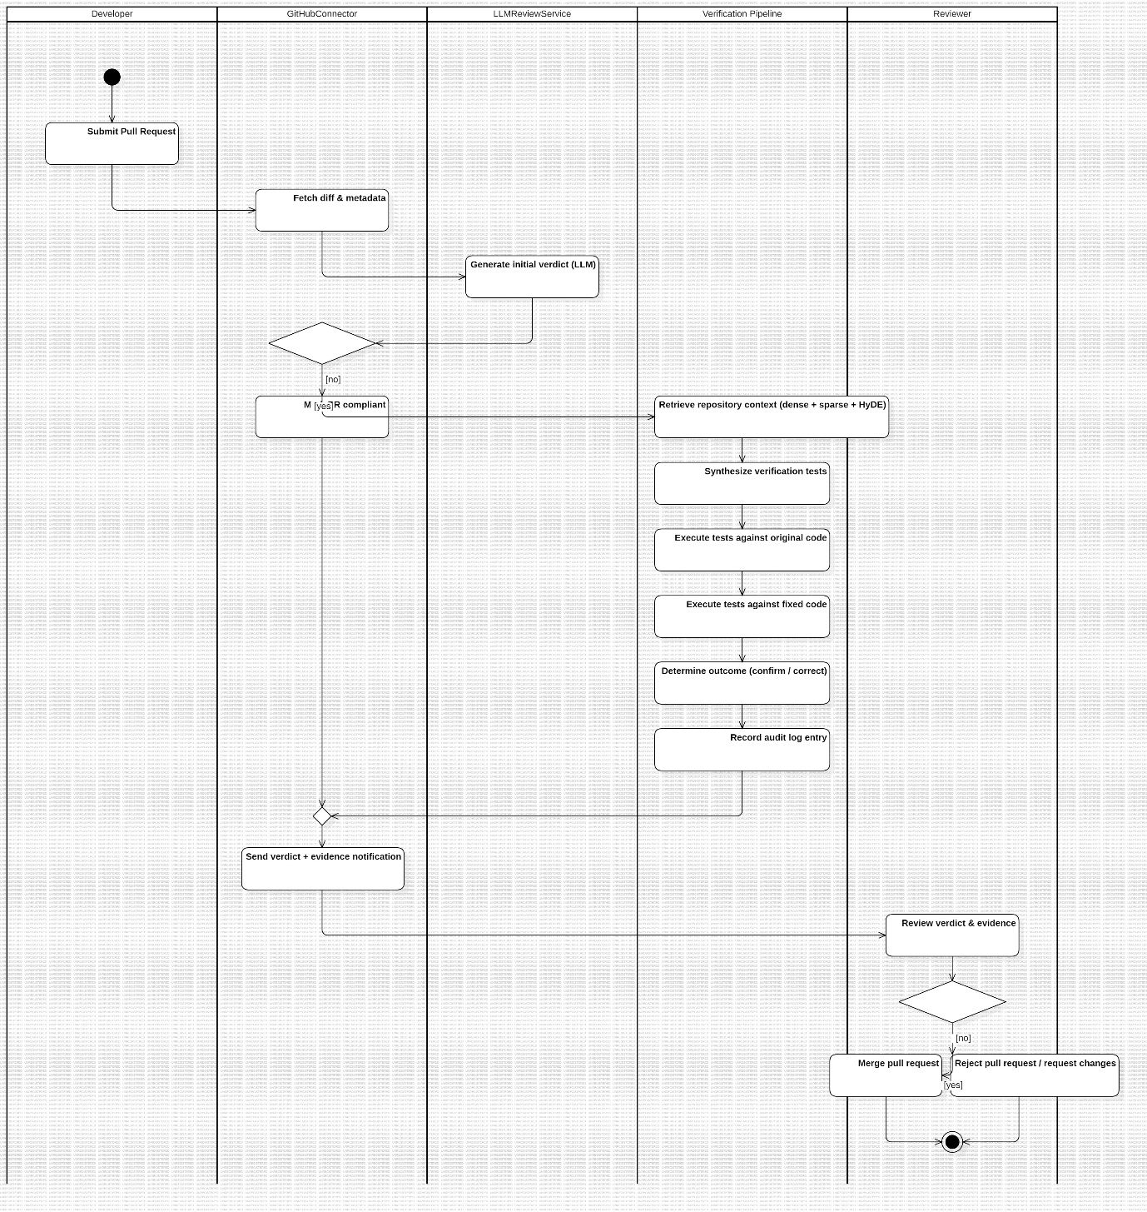

Description of the Diagram

The diagram represents the behavioral workflow of the Issue-Grounded Repository Comprehension Assistant for handling and verifying a flagged pull request. The system consists of five major participants: Developer, GitHubConnector, LLMReviewService, Verification Pipeline, and Reviewer.

The process begins with the Developer submitting a pull request. The GitHubConnector receives the request and retrieves the relevant code changes and metadata associated with the pull request.

The retrieved information is then passed to the LLMReviewService, which generates an initial verdict using the language model. Based on this verdict, the system follows one of two possible paths.

If the pull request is identified as non-compliant, the verification pipeline is initiated. The pipeline first retrieves relevant repository context using a combination of dense retrieval, sparse retrieval, and HyDE-based query expansion. The retrieved context is then used to synthesize verification tests.

The generated tests are executed against the original code as well as the fixed code. The results of these executions are analyzed by the verification pipeline to determine whether the issue has been correctly addressed. The system then records an audit log entry containing the outcome of the verification process.

If the pull request is considered compliant, the additional verification process can be skipped and the pull request can proceed directly to the result notification stage.

After the verification process, the GitHubConnector sends the verdict and supporting evidence to the developer and reviewer. The Reviewer examines the verdict and evidence and makes the final decision to either merge the pull request or reject the pull request/request changes.

Sequence of Activities
The major activities represented in the diagram are:

- Submit Pull Request – The developer submits a pull request.
- Fetch Diff & Metadata – The GitHubConnector retrieves the pull request changes and metadata.
- Generate Initial Verdict – The LLMReviewService analyzes the pull request and generates an initial verdict.
- Decision – The system determines whether the pull request requires further verification.
- Retrieve Repository Context – Relevant code is retrieved using dense, sparse, and HyDE-based retrieval.
- Synthesize Verification Tests – Tests are generated using the retrieved repository context.
- Execute Tests Against Original Code – The generated tests are executed against the original implementation.
- Execute Tests Against Fixed Code – The same tests are executed against the proposed corrected implementation.
- Determine Outcome – The verification results are analyzed to determine whether the proposed fix is valid.
- Record Audit Log Entry – The verification outcome is recorded for traceability.
- Send Verdict and Evidence Notification – The final result and supporting evidence are communicated to the concerned users.
- Review Verdict and Evidence – The reviewer examines the verification result.
- Final Decision – The reviewer either approves the pull request for merging or rejects it/request changes.

Methodology / Procedure
As specified in the experiment, the behavioral diagram can be developed using the following steps:

- Identify the major elements and components involved in the selected system scenario.
- Identify the behavior of the system elements and their interaction with external interfaces.
- Determine the sequence of activities performed during the selected workflow.
- Identify the decisions and alternative paths in the workflow.
- Represent the activities and their interactions using appropriate UML notation.
- Connect the activities according to their logical flow.
- Review the completed diagram to ensure that the system behavior is represented correctly.

Observation
The behavioral diagram shows that the system follows a sequential workflow beginning with pull request submission and ending with reviewer approval or rejection. The diagram also represents an alternative path based on the initial LLM-generated verdict. A non-compliant pull request undergoes repository context retrieval, test synthesis, test execution, and verification, whereas a compliant pull request can bypass the detailed verification process.

Conclusion
The behavioral model provides a clear representation of the dynamic workflow of the proposed system. It demonstrates how the Developer, GitHubConnector, LLMReviewService, Verification Pipeline, and Reviewer participate in processing and verifying a pull request. The diagram also represents decision points and alternative execution paths, thereby providing an understanding of the system's runtime behavior.

